Coffee Sales Dashboard

12-month overview of customer behavior and product performance

Author: Lajos Almasi

Date: 2025. 04. 30

## Dashboard Overview

This report is based on a sample dataset downloaded from Kaggle.com. The dataset contains detailed records of coffee sales from a vending machine and spans from March 2024 to March 2025 capturing daily transaction data.

Tools used: Power BI, PostgreSQL, TablePlus

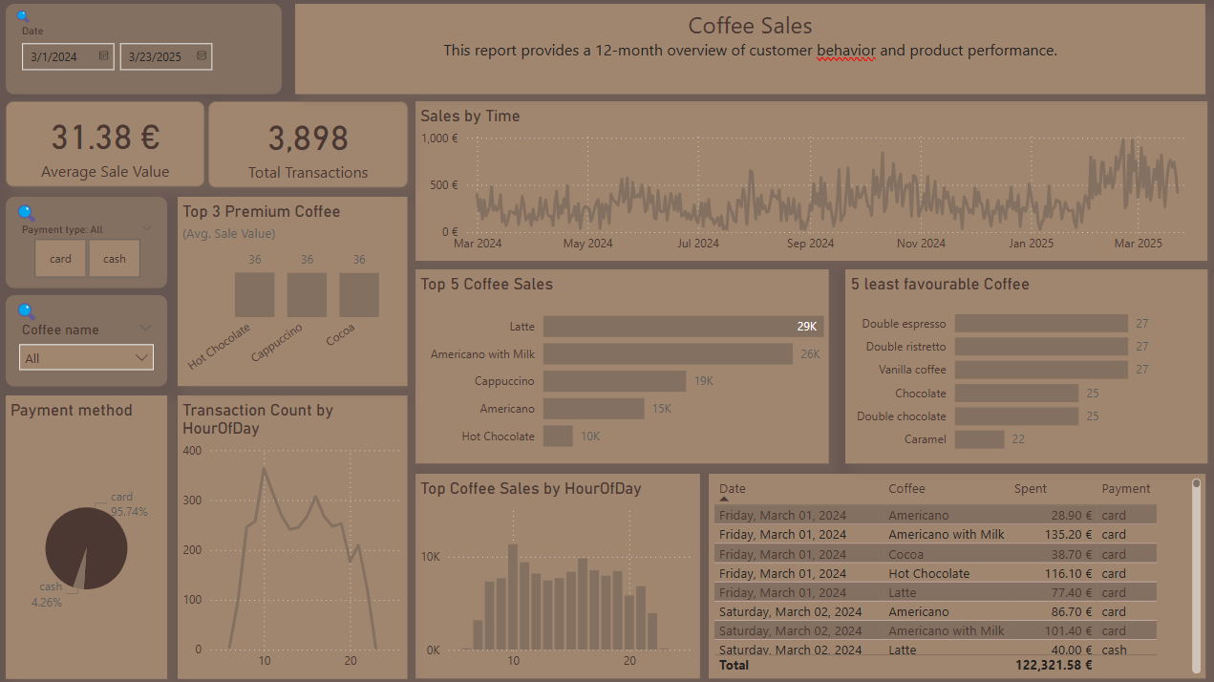

## Visualizations

1. **Average Sale Value & Total Transactions (KPI Cards)**

* The average amount spent per purchase is €31.38, reflecting typical customer spending.
* A total of 3,898 transactions occurred during the selected period.
* These KPIs provide a quick snapshot of overall volume and revenue.
* Both values are dynamically filterable using slicers.

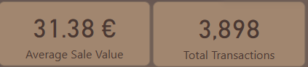

1. **Sales by Time (Line Chart)**

* This visual track daily revenue trends over the 12-month period.
* Seasonal fluctuations and peaks in sales are clearly visible.
* It helps identify performance cycles and evaluate the impact of campaigns or external factors.

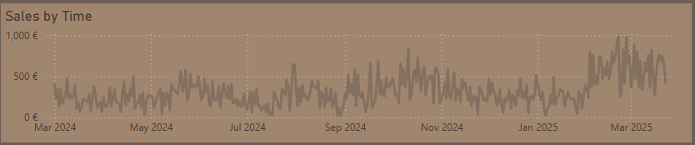

1. **Top 5 Coffee Sales**

* Latte is the top-selling item, followed by Americano with Milk.
* The chart ranks coffee products based on total revenue.
* Useful for identifying high-performing items and focusing marketing efforts.

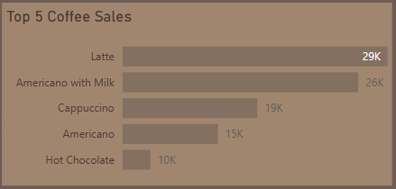

1. **5 Least Favourable Coffee**

* These are the least frequently purchased products during the period.
* It highlights low-demand items that may be discontinued or promoted.
* Helps with portfolio optimization and inventory planning.

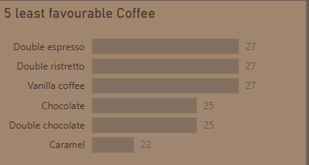

1. **Top 3 Premium Coffee (Avg. Sale Value)**

* Hot Chocolate, Cappuccino, and Cocoa had the highest average transaction values.
* These products may not lead in volume but are valuable in profitability.
* A great complementary view to the top-selling items.

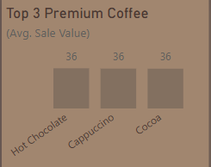

1. **Payment Method (Pie Chart)**

* Most transactions were paid by card (95.74%), with minimal cash usage.
* Useful for payment terminal usage insights and future investment decisions.
* Fully filterable by product or time.

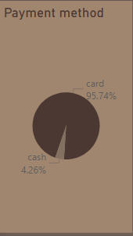

1. **Transaction Count by Hour of Day**

* Peak buying times are between 8 AM and 10 AM, aligning with morning routines.
* Supports planning for refills or staff scheduling (if applicable).
* Useful for time-targeted marketing strategies.

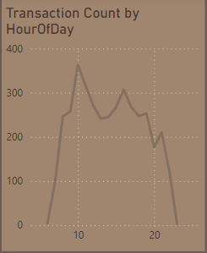

1. **Top Coffee Sales by Hour of Day**

* Shows which coffee types perform best during different hours of the day.
* Reveals customer preferences over time and consumption patterns.
* Compact and informative, ideal for spotting time-based trends.

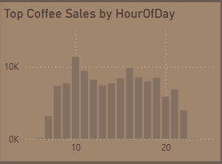

1. **Data Table (Transaction Details)**

* Displays individual transactions with date, coffee name, amount, and payment method.
* Ideal for drilldowns or filtered exploration.
* Includes a total revenue line: €122,321.58.

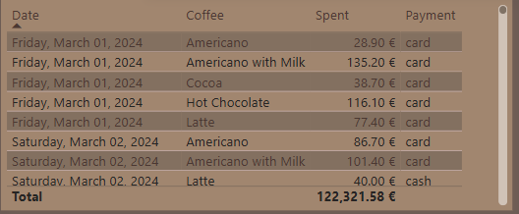

## Key Insights

* Morning peak hours (8–10 AM) account for the highest transaction volume, indicating that most purchases align with customers' commute or workday start.
* Latte and Americano with Milk are the most popular coffee products, representing most of the revenue across the year.
* Despite lower sales volume, products like Hot Chocolate and Cocoa show high average transaction values, highlighting their potential as premium offerings.
* Card payments dominate (over 95%), suggesting low reliance on cash and confirming the importance of a fully functioning card terminal system.
* A small group of products (e.g., Caramel, Vanilla, Double Ristretto) consistently underperform, indicating they could be considered for discontinuation or promotion.

## Recommendations

* Focus **early-day promotions** on high-margin products like Hot Chocolate or Cocoa to boost premium revenue during peak traffic.
* Consider optimizing **product mix** by removing or bundling low-demand items to simplify customer choices and increase throughput.
* Use the insights from **time-based sales patterns** to adjust restocking and maintenance schedules for the vending machine.
* Highlight the top 3 sellers visually at the machine interface to guide quicker decision-making and reinforce bestsellers.